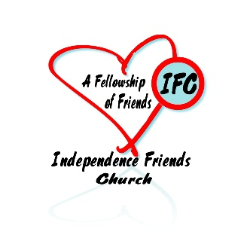**Independence Friends Church**

**Pastoral Search**

Independence Friends Church is seeking a new pastor for our church located in Independence, Kansas in the southeast corner of the state. We are in the process of updating and remodeling our original meeting house. God is doing something new.

**QUALIFICATIONS** (cf. Ps 78:70-72; Mk 10:42-45; Jn 13:1-17; 1 Tim 3:1-13; Titus 1:6-9; 1 Pet 5:1-4)

* Clear testimony of a personal relationship with Jesus Christ
* Genuine calling to bi-vocational Christian service
* Demonstration of sound Christian character (spiritual maturity, emotional stability, moral integrity)
* Evidence of giftedness and competence as a faithful shepherd of God’s people
* Adequate training and experience in Christian ministry
* Ability to communicate clearly, in both verbal and written form
* Competent interpersonal skills, including peacemaking and conflict resolution
* Commitment to pastoral team model of servant leadership

**AREAS OF RESPONSIBILITY** (cf. Rm 12:4-8; 1 Co 12:7-11; Eph 4:7-13; Col 3:23: 1 Pet 4:10-11)

* Model a life of genuine, humble communion with the living God by cultivating a life that is marked by spiritual maturity, personal integrity and a growing love for God and neighbor.
* Meet regularly with members to prayerfully plan and prepare for the overall ministry of the church.
* Preach and teach the Word through careful study and practical application of biblical truth.
* Prefer Expository Style preaching and teaching
* Tech friendly
* Oversee the planning and implementation of corporate worship gatherings of the church.
* Prefer the candidate and/or spouse have ability to lead worship by vocal and/or musical accompaniment.
* Supervise and share in the pastoral care of the congregation, along with the elders and other members.
* Officiate at weddings and funerals as appropriate.
* Participate in annual EFC-MAYM Ministry Conference, Pastor’s Sabbath Retreat and other yearly meeting gatherings and events, as time permit.

For more information about Independence look at the website, <https://www.independenceks.gov/>

See the Independence Friends on Facebook

Please contact Chaplain Renita Butler, Clerk to apply at 620-719-7676 or butlerrenita142@gmail.com.